**Project house**

**Admin module**

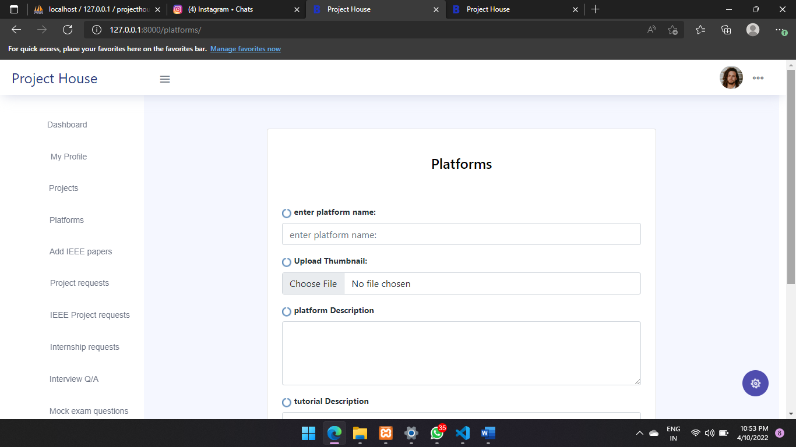

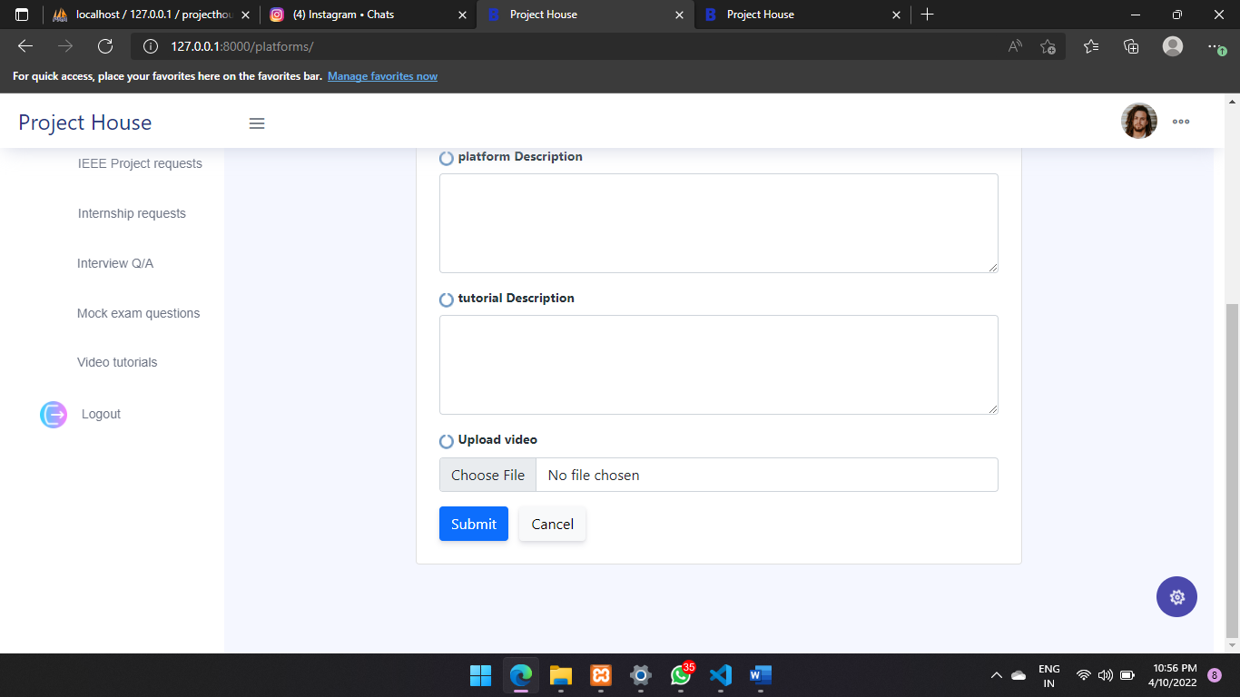

Description:

*This page is created to add platforms to the project house by admins , admins can add details about the adding platforms like thumbnail , tutorial video and their descriptions too*

**user module**

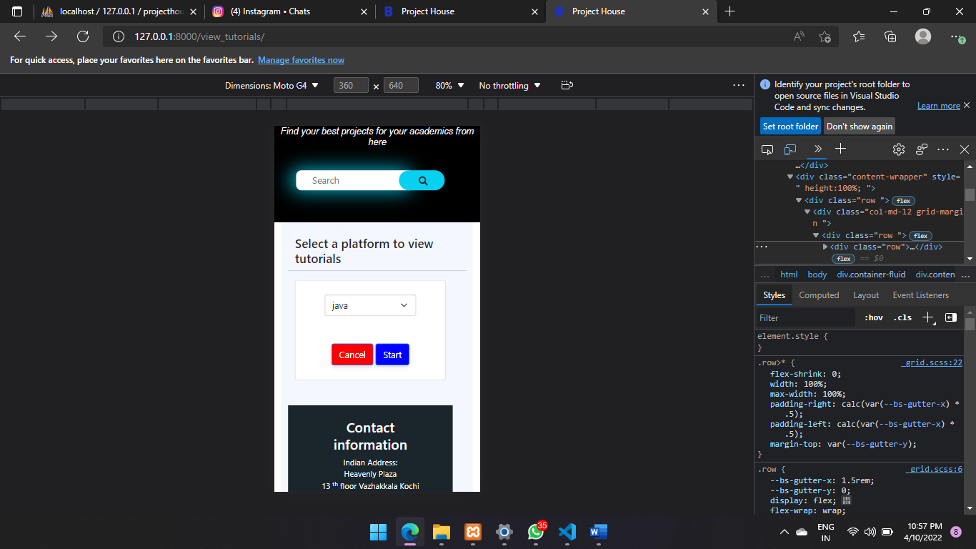

Description:

*In this page user can choose a platform and view the platforms, tutorials added by admins*

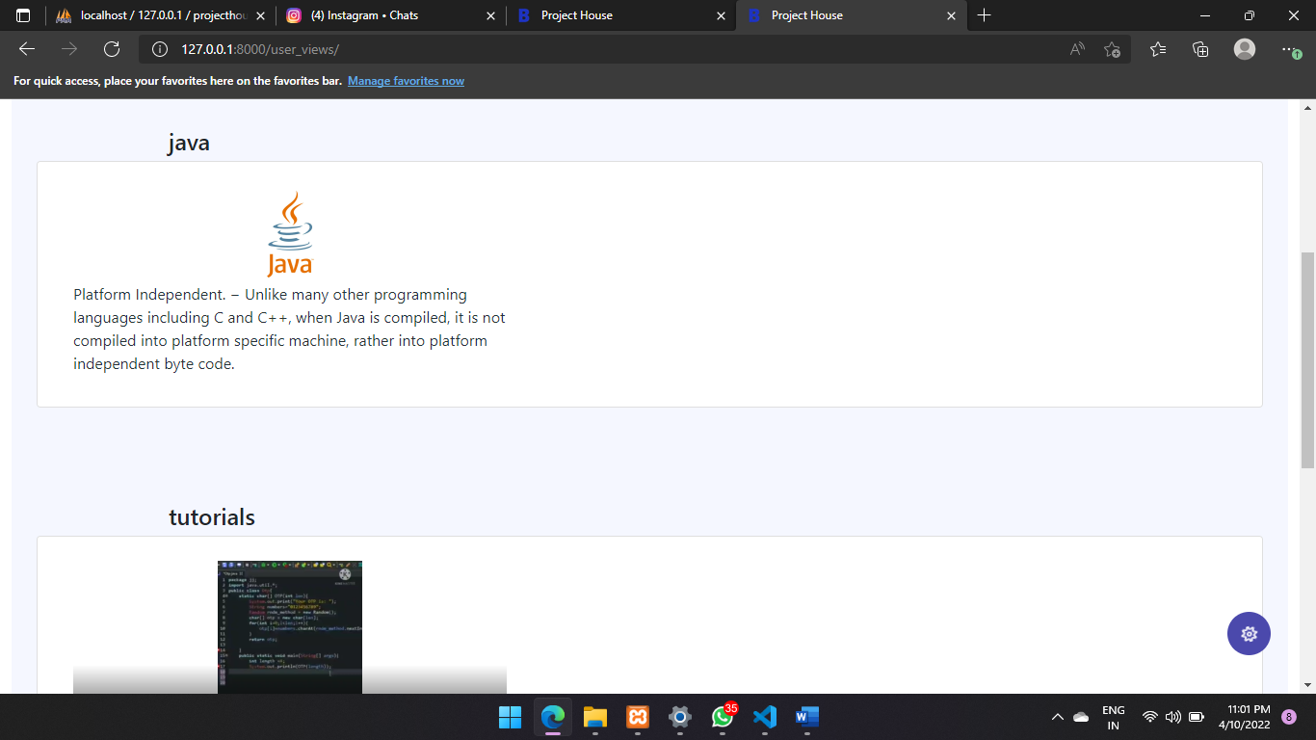

Description:

*In this page user can view the platforms and their tutorials*